Robotics Name: _______________________

Accelerometers for Asteroids

In this lab we’re doing to use the Accelerometer to control a spaceship in the game Asteroids.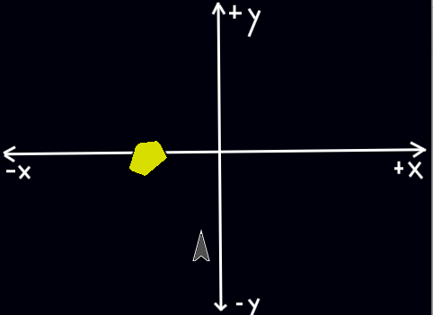

The game starts when you click the green flag.

Asteroids come from the top of the screen and move down.

The player should try to avoid the asteroids by moving the ship using the finch.

**Part 0: The Rules of the Game**

In order to control the ship, we’re going to be using **accelerometer** on the finch.

Fill out the table WITH YOUR TEACHER as a first step towards understanding how to do this.

|  |  |  |  |
| --- | --- | --- | --- |
| If the finch’s orientation is…. | Then the ship should move (CIRCLE ONE) | Code to check finch’s orientation... | Code to move the ship... |
| Left side down |  |  |  |
| Right side down |  |  |  |

|  |  |  |  |
| --- | --- | --- | --- |
| If the finch’s orientation is... | Then the ship should move... | Code to check finch’s orientation... | Code to move ship... |
| Beak up |  |  |  |
| Beak down |  |  |  |

**Part 1: Set Up**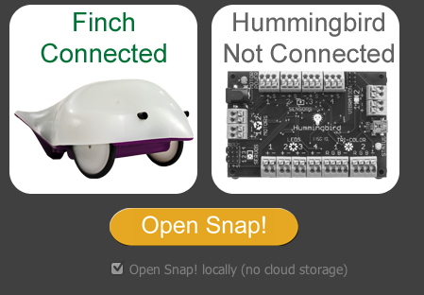

**Connect the Finch to your computer** by plugging in the cord to the USB port on the side of your keyboard.

**Open BirdBrainRobot server on your computer.** Click on the magnifying glass in the top right corner of your screen and type “BirdBrain”. It should open with a screen that looks like this the picture on the right.

**Click Open Snap!**

**Part 2: Build the Controller**

In ***WiiAsteroidsStarter.xml***, EVERY BLOCK YOU NEED TO IS ALREADY PRESENT.

YOUR GOAL IS TO ARRANGE THEM CORRECTLY SO THAT THE SHIP CAN MOVE PROPERLY.

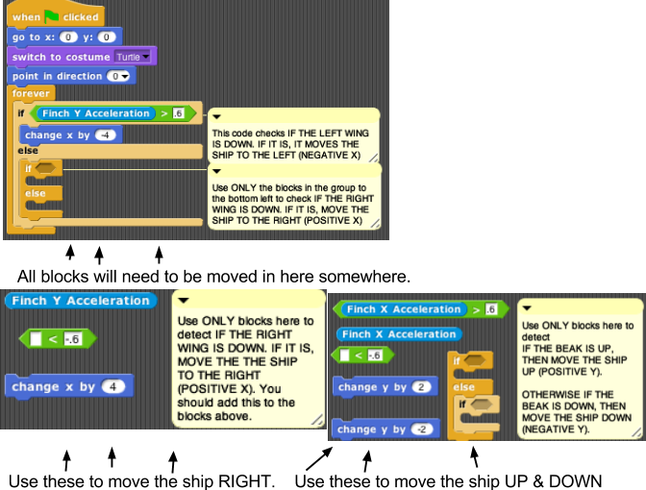

|  |  |
| --- | --- |
| **Task** | **Completed? (To be marked by teacher)** |
| If the finch’s right wing is down, the ship moves to right |  |
| If the finch’s beak is up, the ship moves up |  |
| If the finch’s beak is down, the ship moves down |  |

**Part 3: Detect Collisions**

For this part of the lab, you’ll try to detect collisions between 

* the ship and the asteroid

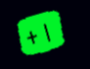

* the ship and the health containers

Much like your Grumpy Fowls project from IntroCS, you’ll need to use a **conditional** with a **boolean expression**. See if you can ADD code that will perform the following tasks.

|  |  |
| --- | --- |
| **Task** | **Completed? (To be marked by teacher)** |
| If the space ship touches an asteroid, the ship’s costume changes to an explosion |  |
| If the space ship touches an asteroid, the whole game stops |  |
| If the space ship touches a health container, the ship says “+1” |  |
| If the space ship touches a health container, the ship updates total score and says its total score |  |